***CASE STUDY: Car rental***

Car rental companies own a number of cars and a number of sites where cars are parked when not in use. Customers rent cars for a period of time (having made a reservation, or not) and return them.

We focus on company CARS.

The current process (AS IS), is as follows.

A customer may reserve a car, using the company web site, or the call center (this step is optional).

A customer steps into the office close to the rental car parking site and completes the first step of the *check out*. The contract for the rental is defined (period of rental, name of driver, related ID document and driving license, insurances, damage deposit, partial and total fees, credit card), signed by both parties, and the payment for the rental is completed (payment has two parts, rental and damage deposit – the latter is normally returned at the end of the rental). Further, a specific car (identified by its tag) is assigned to the rental.

Then the customer walks to the car parking site. Here the second part of the check out happens.

An employee checks with the customer the car and lists all visible damages on the car in an annex to the contract. Also this annex is signed by both parties. Then the employee hands the car to the customer (this of course includes the keys) and the rental starts.

The final step is *check in*. The customer drives the car to parking site. An employee receives the car and the keys, checks with the customer for new damages. If there are damages another process starts (we leave this process out of this analysis). At this point the rental ends. The company issues an invoice and possibly returns the damage deposit to the customer.

TO BE process.

The idea is to improve the process by introducing the same innovations used by car sharing companies.

A customer has first to define an account with CARS. In this step the customer uploads his documents (ID, driving license) and a credit card. If all is right CARS approves and the customer can later rent cars. This step can be performed on a PC or smart phone. In any case the customer has to install the CARS app on her smartphone.

When a registered customer wants to rent a car she has to do a reservation (via app or PC).

Check out works as follows. The customer walks directly to the rental car parking, via the app she signals that she wants to start the rental. The app answers with position and tag of the assigned car.

When the customer is close to the car she asks, via the app, to open the car. The system opens the car (the car needs to be modified via a device connected to the cellular network and capable of controlling some car functions, like door open/close). The keys are inside the car. The customer starts the car, and the rental.

The check in is similar. The customer parks the car in the rental car parking, stops the car, exits, and asks the app to close the car. At this point the rental is over.

Invoicing and payments proceed through the credit card.

Damage deposits and possibly damage reimboursements are avoided, introducing by default an insurance to cover all.

*LAB*

*Models to software functions*

1 given the process model and the data model (in TO BE version), list the software functions needed to support the business processes. Double check consistency of process model, data model and software functions. If you find errors in the process or data model, signal and fix them.

2 search the internet for software applications capable of providing the listed software functions

3 select, at high level, a short list of 3 suitable software applications

4 select the most suitable

Note: in a real case the software applications currently used by the company should be considered too. In our case study the technical model (including the application portfolio) is very high level, and does not list the actual software applications used.

Contents

B – TO BE 4

1 Organizational model 4

2 Process model 5

Process list 5

Reservation 5

Onboarding 6

Checkout 7

Checkin 7

4 Data model 7

5 Technical model 8

6 Software functions needed 9

# B – TO BE

## 1 Organizational model

Car rental company

Accounting

Finance

Human resources

IT area (manage web site and all IT services)

Legal department

Sales and marketing (will implement reservations)

Reservation office

Customer assistance (accidents, ..)

Car management (“manufacturing”)

**Car remote control (ADDED)**

Local agency (repeated many times, in each city, airport, railway station..)

(geo structure)

**~~Office (CANCELED)~~**

Parking site

Maintenance (cleaning, small repairs) (full maintenance is outsourced to external

workshops)

Purchase office (for cars)

Customer

Payment circuit (credit card , bank circuit)

(yellow = specific to the part actually described in case study. Non yellow, assumptions about part of CARS not described in case study)

In the new organization the office part of the local agency is canceled, since damage check and car key delivery are also avoided. Car damage is managed through insurance (see above), keys are not used anymore, the cars are open/closed via remote control. As a consequence the related infrastructure has to be put in place (Car remote control OU). Car remote control works for all local agencies.

Since the organization structure changes, besides process and technology, this is a third order change

## 2 Process model

### Process list

|  |  |  |  |  |
| --- | --- | --- | --- | --- |
| Process name | In | out | Description | OU involved |
| Onboarding |  | Registered customer | Customer defines and account with CARS, enters driving license, ID, credit card. CARS validates everything, creates account for customer, defines fees, collects signature on agreement | Reservation office, customer, payment circuit |
| Reservation |  | Reservation complete | Customer enters his account, selects location, dates, type of car | Reservation office, customer |
| Checkout |  | Rental started | Allocate car, open car | Customer, Car remote control, |
| Checkin |  | Rental ended | Return car, close it, define payment | Customer, Car remote control  payment circuit |
|  |  |  |  |  |

We need to introduce a new process, onboarding, where a customer defines an account and inserts all her relevant documents (ID, license, credit card), so to avoid this part in the checkout process.

### Reservation

Same as in AS IS

### Onboarding

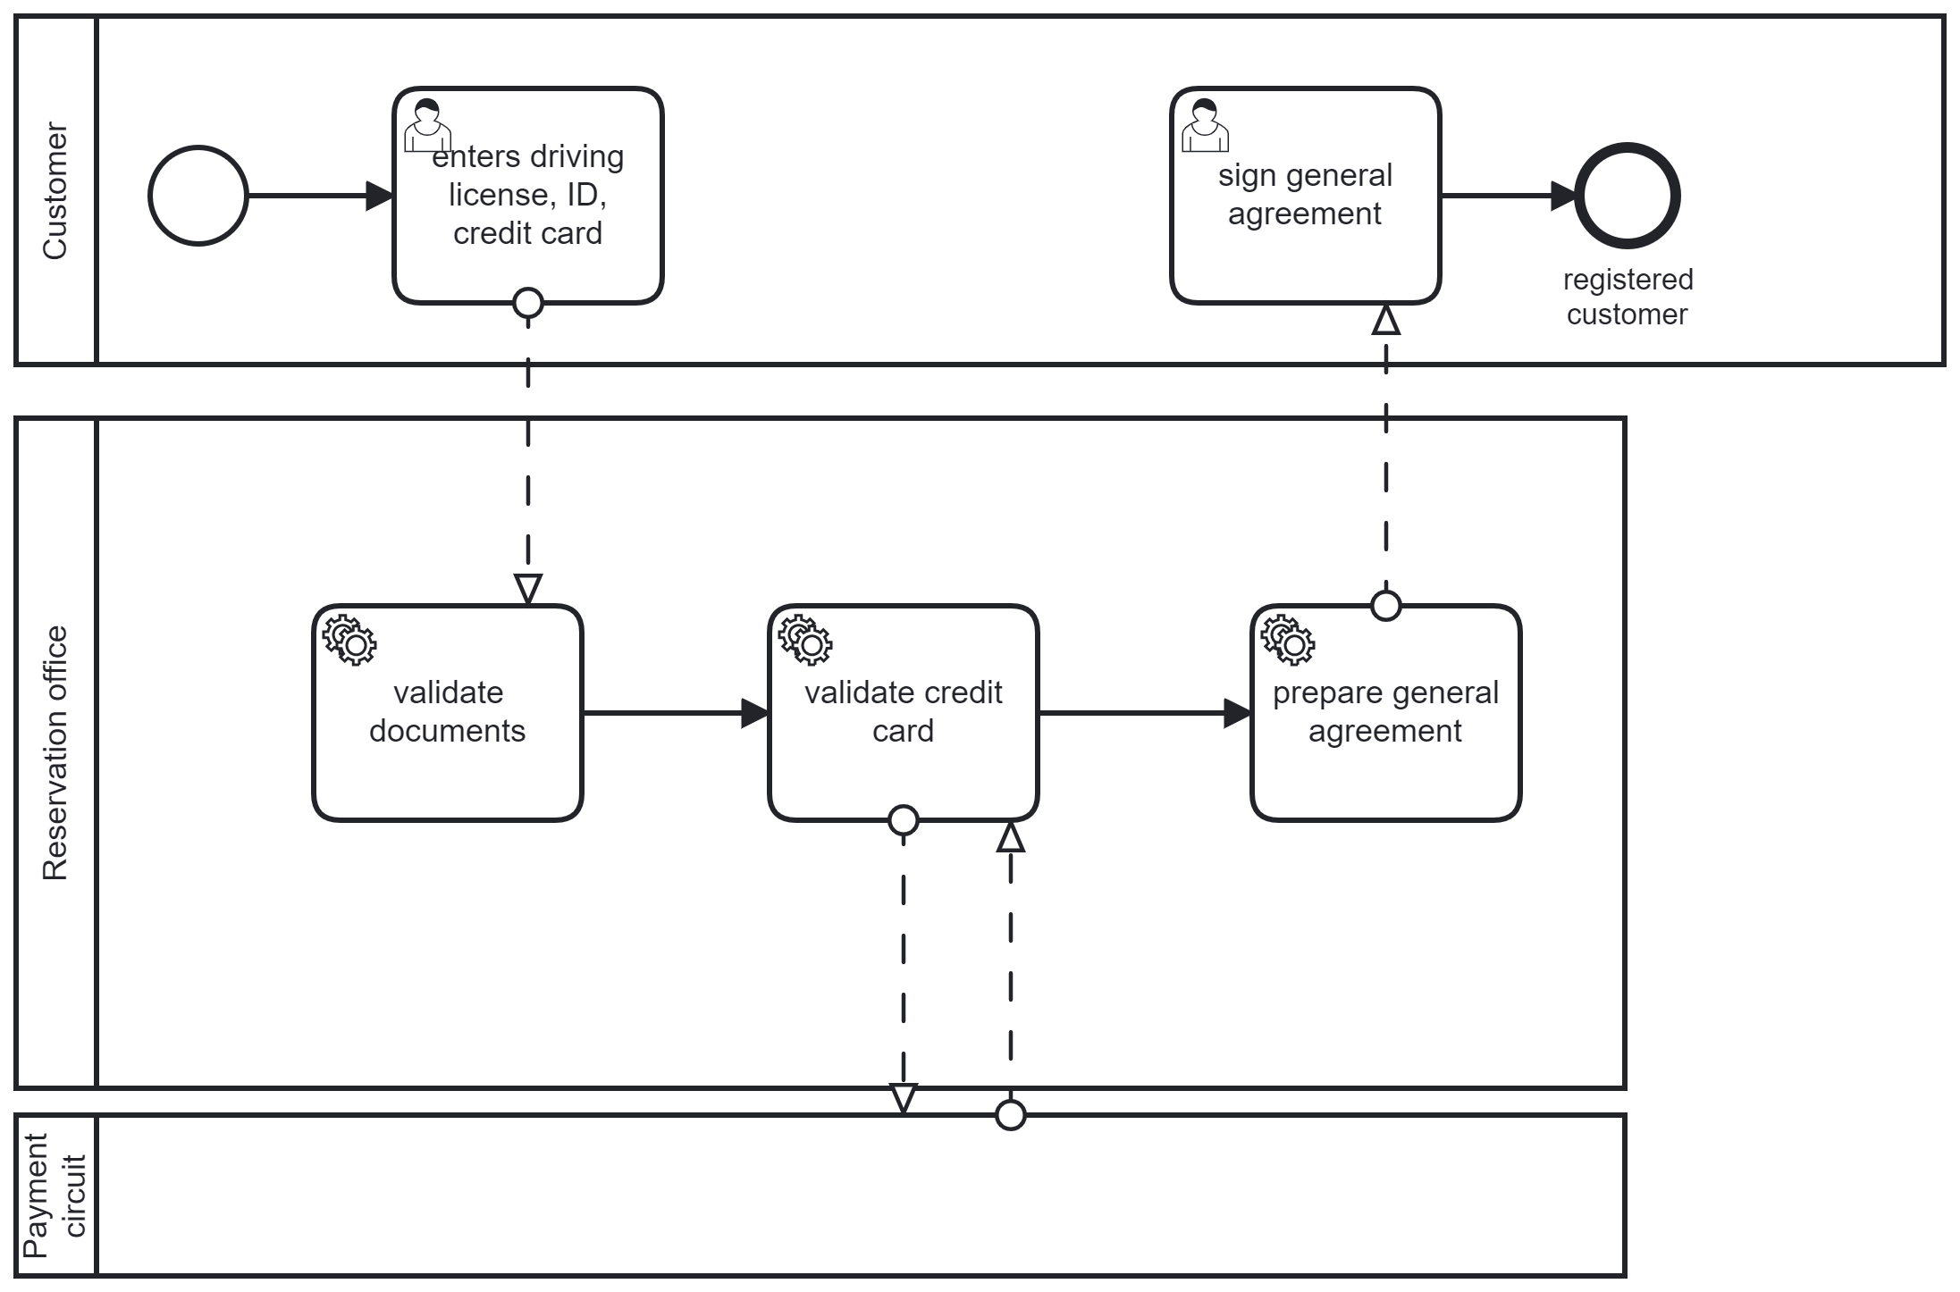

### Checkout

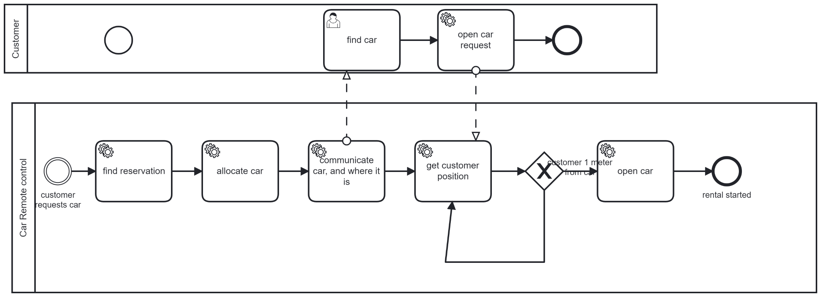

### Checkin

TBD

## 4 Data model

## 5 Technical model

Application portfolio

(each artifact is an application in the application portfolio)

Rental management, HR, Accounting, Finance, Purchase management, Reservation, CRM ,

CARS mobile app, firmware, remote car control (yellow = added in TO BE) Remark also the hw device to be added in each car to control open/close doors, interacting via CAN BUS with existing electronics on board of car.

Deployment diagram

## 6 Software functions needed

|  |  |  |
| --- | --- | --- |
| Process | Task | Software functions |
| onboarding | Enter driving license, id, credit card | Create web page for onboarding  Validate fields (all fields for ‘account’ and ‘person’ must be filled, name must be literals only..)  Collect and store ‘account’ and ‘person’  Collect picture (jpg, png) for driving license, id, credit card  Ocr driving license, recognize name, surname, license type, exp date  Ocr id, recognize name, surname, exp date of document, issuer of document  Ocr credit card, recognize …  Store documents (credit card, driving license, ) both as jpg and textual fields  Create account |
|  | Sign general agreement | Manage 2FA signature (generate OTP, send OTP to email or send OTP to cell number, receive OTP on web page, compare, check expiration of OTP)  Store agreement , attach agreement to customer  Create PDF, Send pdf to customer |
|  | Validate documents | Compare name and surname on ID and name surname of Person  Compare name and surname on driving license and name surname of Person  Compare name and surname on credit card and name surname of Person  Check exp date of driving license (at least one month from now)  Check type of driving license (at least B..)  ? send driving licence number to ministry of transport and ask validation? |
|  | Validate credit card | Send to credit card circuit all fields and ask for validation |
|  | Prepare general agreement | Create a customize general agreement (add name of customer, date ..)  Store customized ga and attach it to customer |
| checkout | Find reservation | Given ‘customer requests car’ event, retrieve customer ID  Given customer id, and current date+time, find reservation attached to customer id for date and time, return reservation ID  Given reservation id, retrieve reservation  Given reservation id, check validity (payment successful, ..) |
|  | Allocate car | Given reservation ID, find location attached to reservation, find car type reserved  Given location, given car type, return list of available car of that type  Given list of available cars, select one (criterion? Random?) |
|  | Communicate car | Send to customer car (tag, color, make and model), and position (lat long) of car |
|  | Find car | Navigate to (from current position to car position) |
|  | Open car request | Create button ‘open car’ on app used by the customer  Check position of customer vs position of car (must be at most 1 m apart)  Send ‘open car’ request |
|  | Get customer position | Get lat long of customer |
|  | Open car | Receive ‘open car request’  Send open car command to car  Send close command to car  Create ‘Rental’, set start date time  Attach ‘rental’ to reservation’  Set ‘reservation’ state to ‘complete’  Attach ‘car’ to ‘rental’  Set ‘car’ state to ‘in rental’ |

Rental management

All functions for managing rental, car, reservation, agreement, customer, document

Ocr application

Identification + authentication

2fa, account management, pwd

Car remote control

Position and state of car

Open close car

Position, navigation of customer / mobile phone

Libraries on mobile phone